Waveform Generator

Waveform Generator Setup: To setup the signal, first the waveform generator is powered on. From there, the parameters button is pressed. Then, the frequency was changed to 80,000 Hz and the Amplitude was changed to 10V. The output was then turned on by pressing the channel 1 button and selecting on. Modulation was added by pressing the modulation button and changing the parameters within those settings.

To test the proper injection signal we captured the signal injected across the adversarial coil in the absence of a charging pad or victim device

Waveform generator specifications:

* sin on by 5 ohms resistance
* am modulated by sine
* Frequency = 80 Hz
* Amplitude = 10 Vpp

Below are images of the captured signal across the adversarial coil. This is not the expected output and indicates an error existing in either the connection setup or the input signal

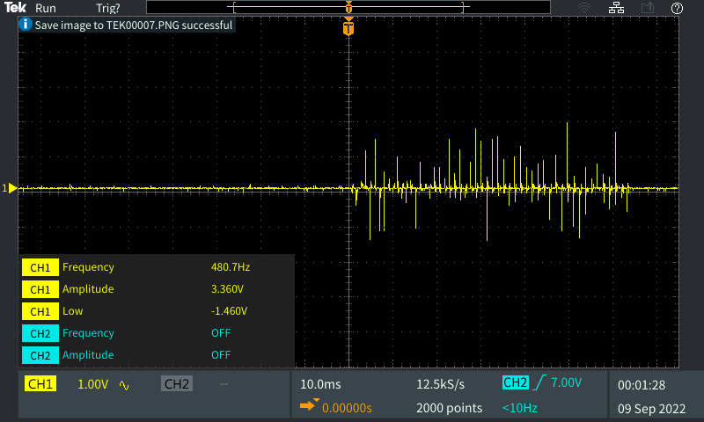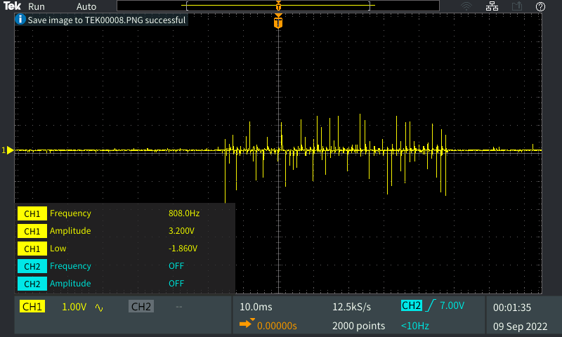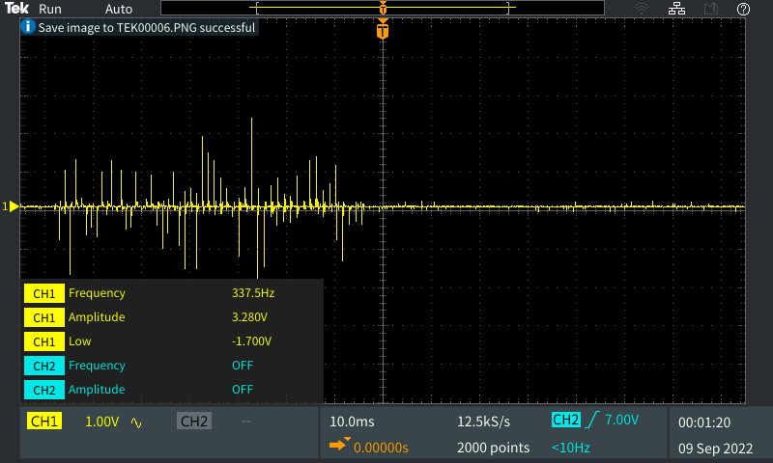

In response to this we tested the raw signal by connecting the waveform generator directly to the oscilloscope probes

Generated signal meeting the expected output

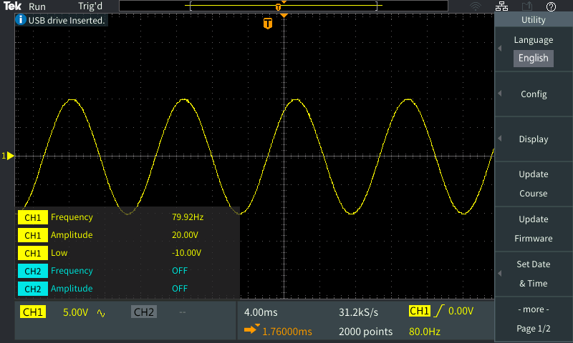

Generated signal with amplitude modulation

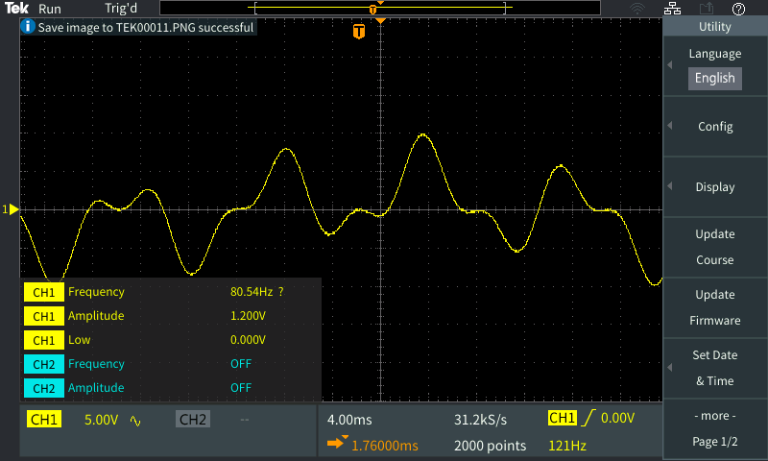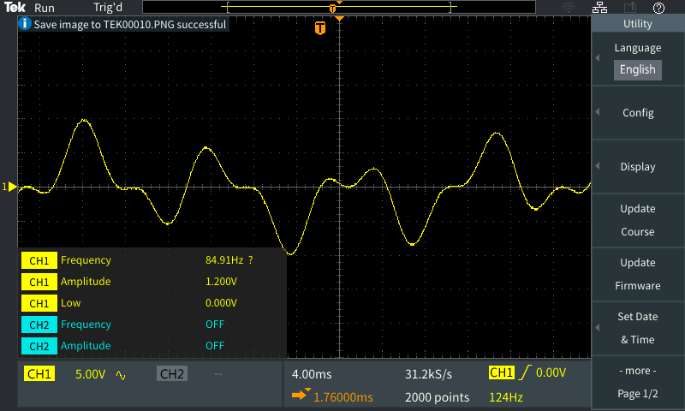

After becoming more comfortable with the equipment we re-attempted the injection using the adversarial coil placed on top of the primary coil with our O-Scope leads attached to the primary coil and the waveform generator leads attached to the adversarial coil. This led to the following image capture.

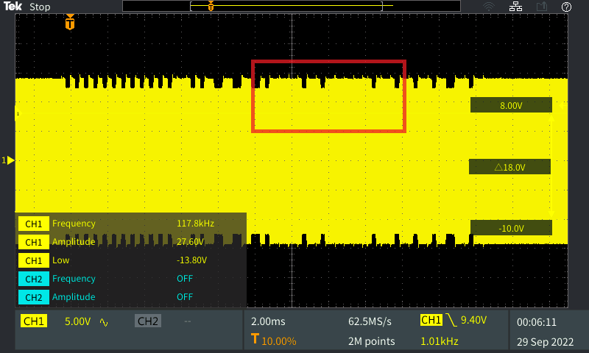

As can be seen inside the red marking box there was a successful injection of our generated waveform into the packet on the primary coil. This means the phone was then transmitted this “injected” packet and proves the possibility of injection style attacks.